**Creating a Test in Universal Java Framework**

**Files Involved:**

1.Feature File

2.Page Object Class

3.Step Definition Class

4.PageObjectManager

5.Configuration.properties

**1.Creating Feature File**

**Write your gherkin**

**2.Create a Step File**

**3.Create a Page File**

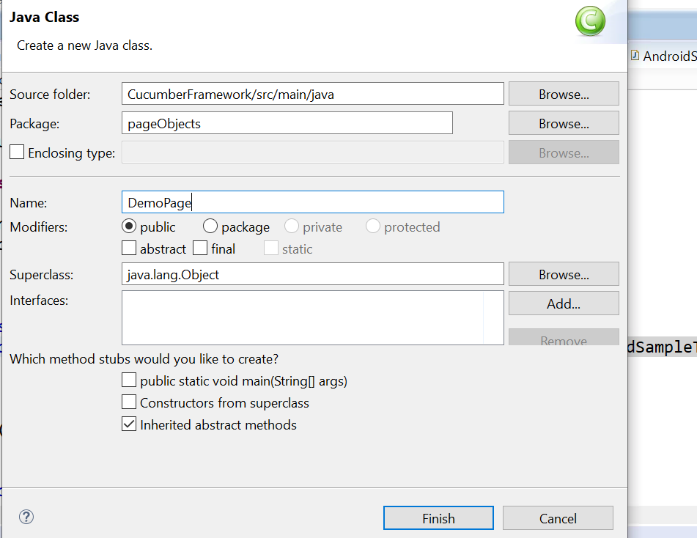

**4.Register your PageObject class in PageObjectManager class**

**5.Create constructor for Pageobject class and initiate Pagefactory**

**6.Create your objects and methods in pageobject class**

**7.Register Pageobject class in Stepdefinitoin class**

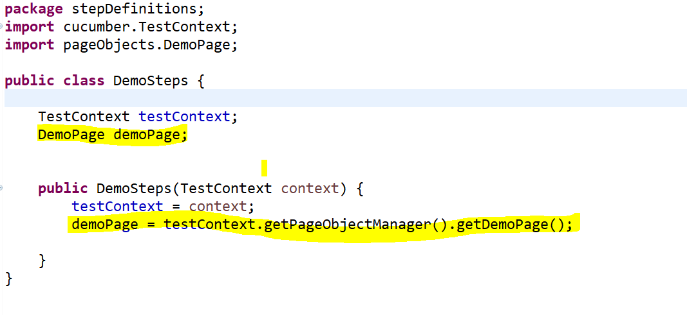

**8.copy Stepdefn from console after running feature**

**9.Paste in Stepdefn class**

**Call your methods in Pageoject class**

**10.Before running ensure your application type and link**

**Mainframe:**

**1.Create Feature**

**2.Create Stepdefn**

**3.Generate steps**

**4.extend mainframe manger and use terminal object**

**For Clarity,**

**Please mail @762269@cognizant.com**